|  |
| --- |
| **Consulting** |
| WMS Setup features for Handheld |
|  |

 



Content

Setup Features for Handheld 3

1.1 Configuration path 3

1.2 Variables 3

# Setup Features for Handheld

## Configuration path

This configuration can be found in the file Setup.resx under the following path

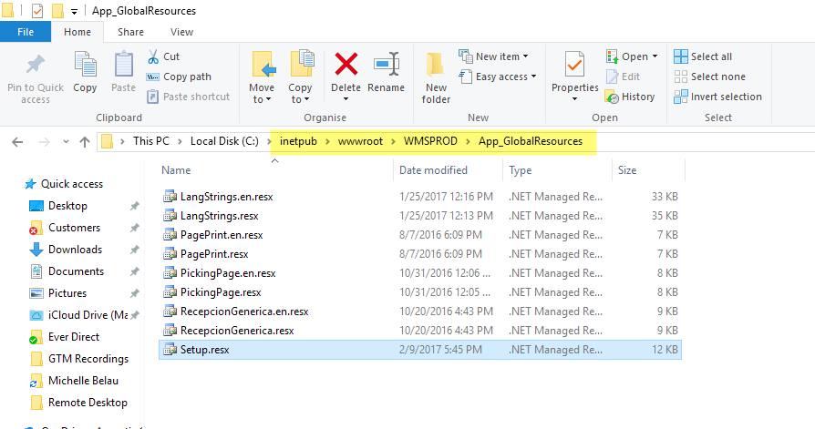

## Variables

* **CodigoDeBusquedaLPDestino**: This option allows you to choose if you need to search an item by Code bar or by its description.
* **PickingPorZona**: This option needs to be activated if you are going to be using your bins by Zones, applying later different zones to specific users.
* **RecepcionMayorOc**: Activating this option will allow you receive a quantity that exceeds the quantity in the Purchase Order.
* **PickingMayorSO**: If this option is active, you will be able to make a picking for a quantity that exceeds the picking quantity of the Sales Order.
* **TransferenciaRapida**: Activating this option will allow you to scan the items you need to transfer from one location to another, one by one, while the quantity decreases, unlike typing the total or partial quantity to be transferred manually.
* **ScanAndNext**: This option will allow you to scan an item and automatically the handheld will proceed to the next page to continue the process. If the option is not activated, you need to use the “next” key in the handheld to continue the process.
* **DisabledNext**: Usually used with the previous option, if this option is not active, the “next” button will not be displayed on your handheld screen.
* **UserWithPickingBins**: If this option is active, you will be able to apply the settings in the WMS Manager page, in which you can assign a picking device to a particular user.
* **UserWithPackBins**: If this option is active, you will be able to apply the settings in the WMS Manager page, in which you can assign a packing location to a particular user.
* **UserWH**: If this option is active, you will be able to apply the settings in the WMS Manager page, in which you can assign a warehouse to a particular user.
* **FilterByDep**: The first screen for any process is the selection of the warehouse you are going to work on, if this option is not active, that first screen will not appear.
* **SelectPrinterbyUser**: If this option is active, you will be able to apply the settings in the WMS Manager page, in which you can assign a printer to a particular user.
* **PutAwayUbiDef**: If this option is active, when on put away process, you will only be able to use the location suggested by WMS, without the option to change that location.
* **ForceSapRecommendation**: If this option is active, on the picking process, you will only be able to use the SAP recommended location.
* **ShippingBlockPartialOrders**: If this option is active, you will not be able make shipping of Sales Orders that are partially picked.
* **DateInputFormat**: This option is to select the date format that will be viewed on the handheld.
* **ReceiptShowPrintBeforeSave**: If this option is active, after you make a reception, it will prompt you to print that reception document. If it´s not, then you will not receive a message, and will need to go manually to the print option to do so.
* **SerialUseSelect**: If this option is active, from put away, to packing, each time you select an item, you will have a dropdown with the serial number to use.
* **LanguageDefault**: The default language with which you will view you handheld site.
* **DisplayRowsProductsPicking**: With this option, you will setup the amount of lines displayed on the Picking Screen.
* **DisplayRowsProductsReception**: With this option, you will setup the amount of lines displayed on the Reception Screen.
* **DisplayRowsPutaway**: With this option, you will setup the amount of lines displayed on the Put away Screen.
* **DisplayRowsPickingOrders**: With this option, you will setup the amount of lines displayed on the picking ticket Screen.
* **DisplayQuantitiesFormat**: With this option you can select the amount of 0 (zeros) displayed on the handheld.
* **AutomaticBatch**: If you have an item setup with batch configuration, every time you have to select the item on the handheld side, it will first ask you the name of the batch. If this option is activated, and configured properly on the WMS Manager side, it will use that information and not prompt you for it when selecting the items.